**Project Report**

|  |  |
| --- | --- |
| **Product Name** | Advanced Certificate in Web Development |
| **Qualification Name (NICF)** | ITSF - Advanced Certificate in Information Technology (Application Development) |
| **Product Name** | Front End Web Development |
| **Module Name (NICF)** | ITSF - Front End Web Development |

|  |  |  |  |
| --- | --- | --- | --- |
| **Student name** | | **Assessor name** | |
| Wildan Luqmanul Hakim | | Ms. Anindita Bose, Mr. Rahul Raghubanshi | |
| **Date issued** | **Completion date** | | **Submitted on** |
| March 31, 2022 | May 10, 2022 | | May 10, 2022 |
|  | | | |
| **Project title** | **Development of website for a Training Organization** | | |

|  |
| --- |
| **Learner declaration** |
| I certify that the work submitted for this assignment is my own and research sources are fully acknowledged.    Student signature: Date: May 10, 2022 |

**Content**

1. Project background
2. Project Objectives
3. Requirement Specifications
4. Task 1
5. Task 2
6. Task 3
7. Task 4
8. Task 5
9. Task 6
10. Task 7
11. Task 8
12. Task 9
13. Task 10
14. Task 11
15. Task 12
16. Task 13
17. Task 14
18. Task 15
19. Task 16
20. Task 17
21. **Project Background**

Website is a medium used to accommodate text data, images, sounds, and animations that can be displayed on the internet and can be accessed by computers connected to the internet globally. Website is a computer network-based information media that can accessible anywhere at a relatively low cost.

in this case the ABC Learning Center makes a website-based learning that will make it easier for peoples to access it anytime and anywhere, ABC Learning Center provides various courses such as Learn Java, Learn Python, and many others. at ABC Learning Center you will get a cheap course price, and of course with a reliable mentor who is ready to help you.

The competition is so tight that ABC Learning center continues to move forward to be the best in technology-based learning courses.

# Project Objective

ABC Learning Center’s business goals:

* + Improve branding image
  + Increase the number of monthly qualified leads by 20%.
  + Make course helpful for customers
  + Make visitors fun with the course

ABC Learning Center’s website goals:

* + Easy to access and navigate to obtain latest information
  + Accessible 24/7
  + Making simple platform Lead generation

Tools & platform used

* + Figma for wireframe and storyboard design
  + Visual Studio Code for development
  + Microsoft Word for document
  + Microsoft Powerpoint for presentation
  + Following, but not limited to, browsers are used

1. Google Chrome

# Requirement Specification

## Scope

* + Display the content relevant to the courses
  + Lead Generation Form
  + Lead Administration

## Out of Scope

* + Integration with database
  + User administration – login, logout, user registration,
  + Search Engine Optimization
  + Backup site
  + Responsive page for administration

## Functional Requirements

Following features and pages should be available in the website.

1. Common Content
   1. Header

In the web page layout, the header is the upper (top) part of the webpage. It is definitely a strategic part of the page as the area which people see before scrolling the page in the first seconds of introduction to the website.

* 1. Footer

The section of content at the very bottom of a web page. It typically contains a copyright notice, link to a privacy and link to sitemap.

* 1. Navigation

The act of clicking and looking through resources on the internet, such as the various pages that make up a website

1. Home Page

The home page is the introductory page of a website. it may also serve as a landing page to attract visitors. In some cases, the home page is a site directory, particularly when a website has multiple home pages.

1. About Us Page / Profile Page  
   The primary purpose of an about us page is to inform the reader about the company and its operations. This is a straightforward goal that nearly all businesses have to fulfill in some fashion or another. However, there are other reasons why about us pages are common fixtures on business websites.
2. Course Listing Page

On the page in the customer can choose the desired course, for the ABC learning center there are 4 courses :

* 1. Learn Java
  2. Learn Python
  3. Learn .NET
  4. Learn Microsoft Office

1. Course Details Page

The course details will be displayed on this page. We will show the course description, what the student will learn, and a testimonial, but customer can see only 2 detail course :

* 1. Learn Java
  2. Learn Python

1. Course Schedule Page

The course schedule page will display the course schedule. The schedule will take the form of a table, with the topics and dates of the courses listed inside. but customer can see only 2 course

schedule page :

* 1. Learn Java Schedule
  2. Learn Python Shedule

1. Contact Us Page

This page contains a form that we can use to get the latest notifications and company contact information to contact the owner or administrator of the website.

1. Lead Registration Course Page

The lead registration page is a page that includes a form that prospective students can fill out if they want to enroll in a course. There are several fields that must be filled :

* 1. Full Name
  2. Email
  3. Contact Number
  4. Select Gender
  5. Select Course

1. Thank You Page

If we submitted the form on the lead registration page, this registration thank you page will be displayed. This page will include a message to the register as well as a thank you.

1. Lead Administration Page

This page is used to manage the registers. This page is only accessible to administrators. This page is not linked throughout the website and can only be accessed through a specific link. The administrator has access to the register data via CRUD (Create Read Update Delete).

* 1. Add – to add new lead
  2. List – to list the leads
  3. Edit – to update the lead details
  4. Delete – to delete the leads

1. Sitemap Page

The sitemap page will include all links to specific pages on our website. This section contains only navigation to help people find a specific webpage on our website.

1. Privacy Policy Page

This page is a statement or legal document that describes how a company or website collects, manages, and processes customer and visitor data.

## Non-functional Requirements

1. Branding
   1. ABC Learning Center logo
   2. ABC Learning Center domain name as abc.com
   3. ABC Learning Center corporate color scheme
2. Following browsers but not limited to are to be supported.
   1. Google Chrome
   2. Microsoft Edge
   3. Mozilla Firefox
   4. Safari
   5. Opera
3. Website must be able to scale when traffic volume increase.
4. Website must be available 24/7 with at least 99.9% uptime.
5. Website pages must load within 3 seconds.
6. All data store must be secured.

## Technical Requirements

1. Software
   1. Web Server: Tomcat 9/Apache 2.4
   2. Editor: Visual Code Studio
   3. Browser: Google Chrome and All Browser
   4. Programming Languages: HTML, CSS, JavaScript, jQuery
   5. Operating System: Windows 10 and above. Mac 10.11 and above
2. Hardware
   1. CPU : Intel Core Pentium 4 or later
   2. RAM : 4 GB
   3. Screen Resolution : 1280x1024 or larger
   4. Harddisk : 10 GB Minimum

# Task 1

## Task Statement:

List and document features in a requirements specification document

Include sections for Website, Lead Generation form and its Administration.

Include it as part of the Project Report

## Solution:

**Scope**

* + Display the content relevant to the courses
  + Lead Generation Form
  + Lead Administration

## Out of Scope

* + Integration with database
  + User administration – login, logout, user registration, reset password
  + Search Engine Optimization
  + Backup site
  + Responsive page for administration

## Functional Requirements

Following features and pages should be available in the website.

1. Common Content
   1. Header

In the web page layout, the header is the upper (top) part of the webpage. It is definitely a strategic part of the page as the area which people see before scrolling the page in the first seconds of introduction to the website.

* 1. Footer

The section of content at the very bottom of a web page. It typically contains a copyright notice, link to a privacy and link to sitemap.

* 1. Navigation

The act of clicking and looking through resources on the internet, such as the various pages that make up a website

1. Home Page

The home page is the introductory page of a website. it may also serve as a landing page to attract visitors. In some cases, the home page is a site directory, particularly when a website has multiple home pages.

1. About Us Page / Profile Page  
   The primary purpose of an about us page is to inform the reader about the company and its operations. This is a straightforward goal that nearly all businesses have to fulfill in some fashion or another. However, there are other reasons why about us pages are common fixtures on business websites.
2. Course Listing Page

On the page in the customer can choose the desired course, for the ABC learning center there are 4 courses :

* 1. Learn Java
  2. Learn Python
  3. Learn .NET
  4. Learn Microsoft Office

1. Course Details Page

The course details will be displayed on this page. We will show the course description, what the student will learn, and a testimonial, but customer can see only 2 detail course :

* 1. Learn Java
  2. Learn Python

1. Course Schedule Page

The course schedule page will display the course schedule. The schedule will take the form of a table, with the topics and dates of the courses listed inside. but customer can see only 2 course

schedule page :

* 1. Learn Java Schedule
  2. Learn Python Shedule

1. Contact Us Page

This page contains a form that we can use to get the latest notifications and company contact information to contact the owner or administrator of the website.

1. Lead Registration Course Page

The lead registration page is a page that includes a form that prospective students can fill out if they want to enroll in a course. There are several fields that must be filled :

* 1. Full Name
  2. Email
  3. Contact Number
  4. Select Gender
  5. Select Course

1. Thank You Page

If we submitted the form on the lead registration page, this registration thank you page will be displayed. This page will include a message to the register as well as a thank you.

1. Lead Administration Page

This page is used to manage the registers. This page is only accessible to administrators. This page is not linked throughout the website and can only be accessed through a specific link. The administrator has access to the register data via CRUD (Create Read Update Delete).

* 1. Add – to add new lead
  2. List – to list the leads
  3. Edit – to update the lead details
  4. Delete – to delete the leads

1. Sitemap Page

The sitemap page will include all links to specific pages on our website. This section contains only navigation to help people find a specific webpage on our website.

1. Privacy Policy Page

This page is a statement or legal document that describes how a company or website collects, manages, and processes customer and visitor data.

## Non-functional Requirements

1. Branding
   1. ABC Learning Center logo
   2. ABC Learning Center domain name as abc.com
   3. ABC Learning Center corporate color scheme
2. Following browsers but not limited to are to be supported.
   1. Google Chrome
   2. Microsoft Edge
   3. Mozilla Firefox
   4. Safari
   5. Opera
3. Website must be able to scale when traffic volume increase.
4. Website must be available 24/7 with at least 99.9% uptime.
5. Website pages must load within 3 seconds.
6. All data store must be secured.

## Technical Requirements

1. Software
   1. Web Server: Tomcat 9/Apache 2.4
   2. Editor: Visual Code Studio
   3. Browser: Google Chrome and All Browser
   4. Programming Languages: HTML, CSS, JavaScript, jQuery
   5. Operating System: Windows 10 and above. Mac 10.11 and above
2. Hardware
   1. CPU : Intel Core Pentium 4 or later
   2. RAM : 4 GB
   3. Screen Resolution : 1280x1024 or larger
   4. Harddisk : 10 GB Minimum

# Task 2

## Task Statement:

1. Create an Information Architecture & Storyboard for the website
2. Propose the Information flow for a Leads generation form & Its Administration (Login Not Required)
   1. User must be able to Add, Edit, Delete & List leads
3. Include it as part of Project Presentation

## Solution:

This section is documented in the Project Presentation.

# Task 3

## Task Statement:

1. Develop the HTML Pages required for the website
2. Develop the Lead Generation Form & Administration System pages for Lead Generation form Management
3. Include the screen capture as part of Project Presentation

## Solution:

The HTML pages are documented in the Project Presentation.

# Task 4

## Task Statement:

1. Propose & use jQuery Components such as the menu, popup, etc as part of the website.
2. Design the required HTML for jQuery Components
3. Provide screen capture as part of Project Presentation

## Solution:

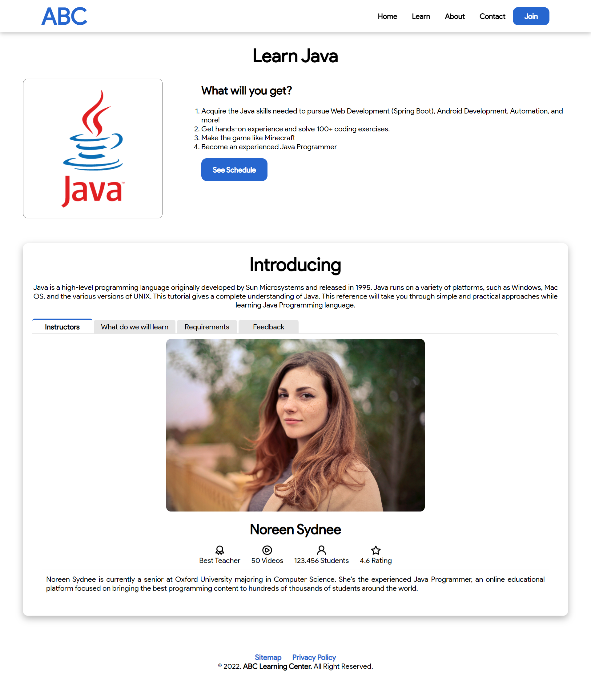. 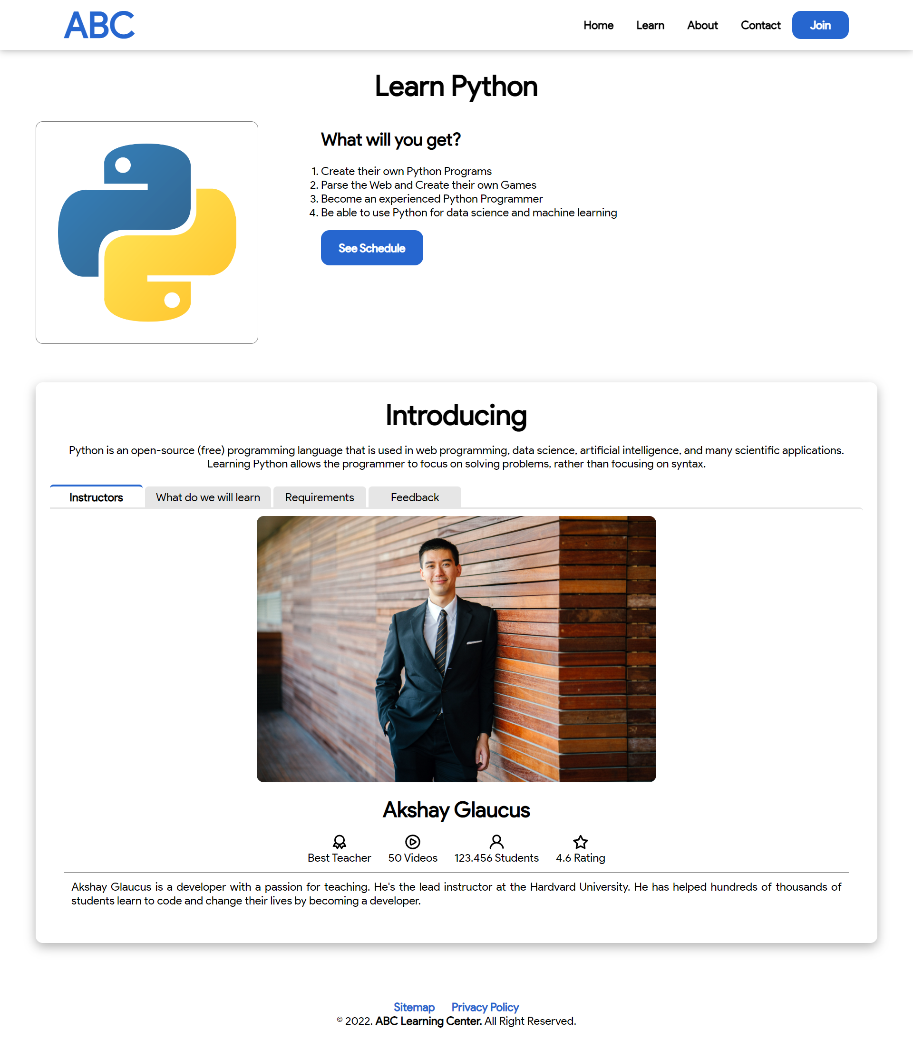

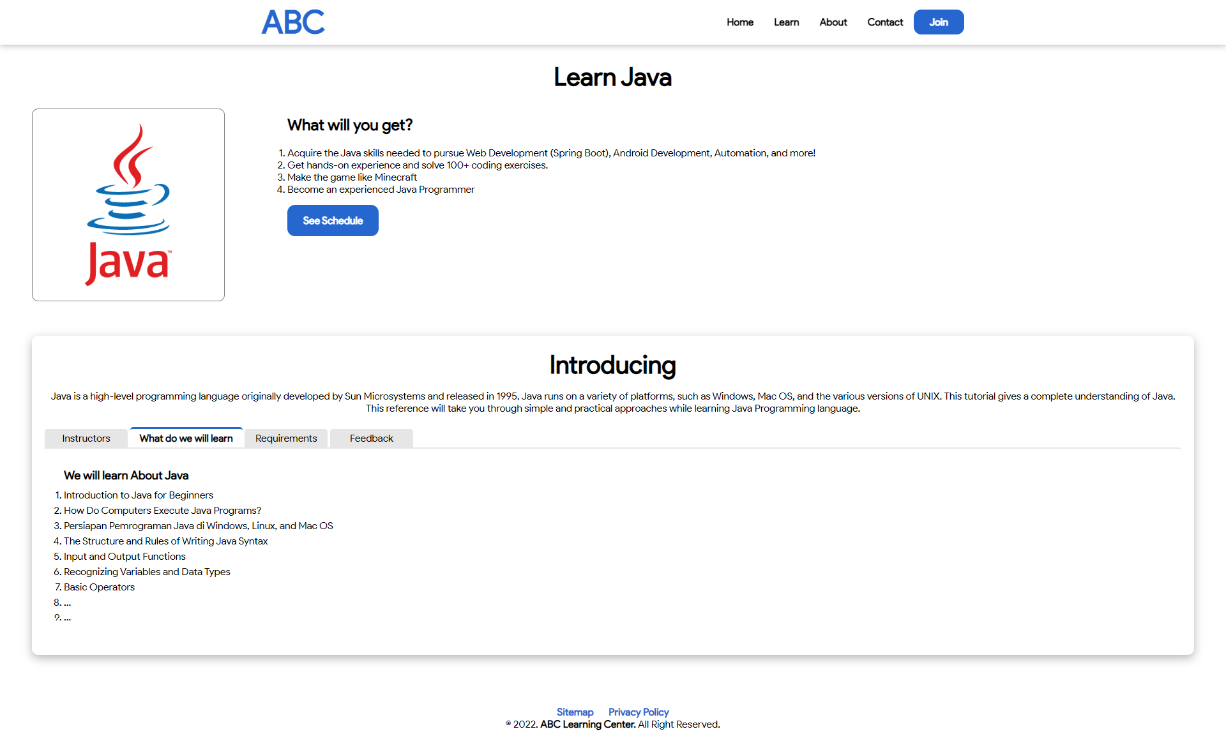 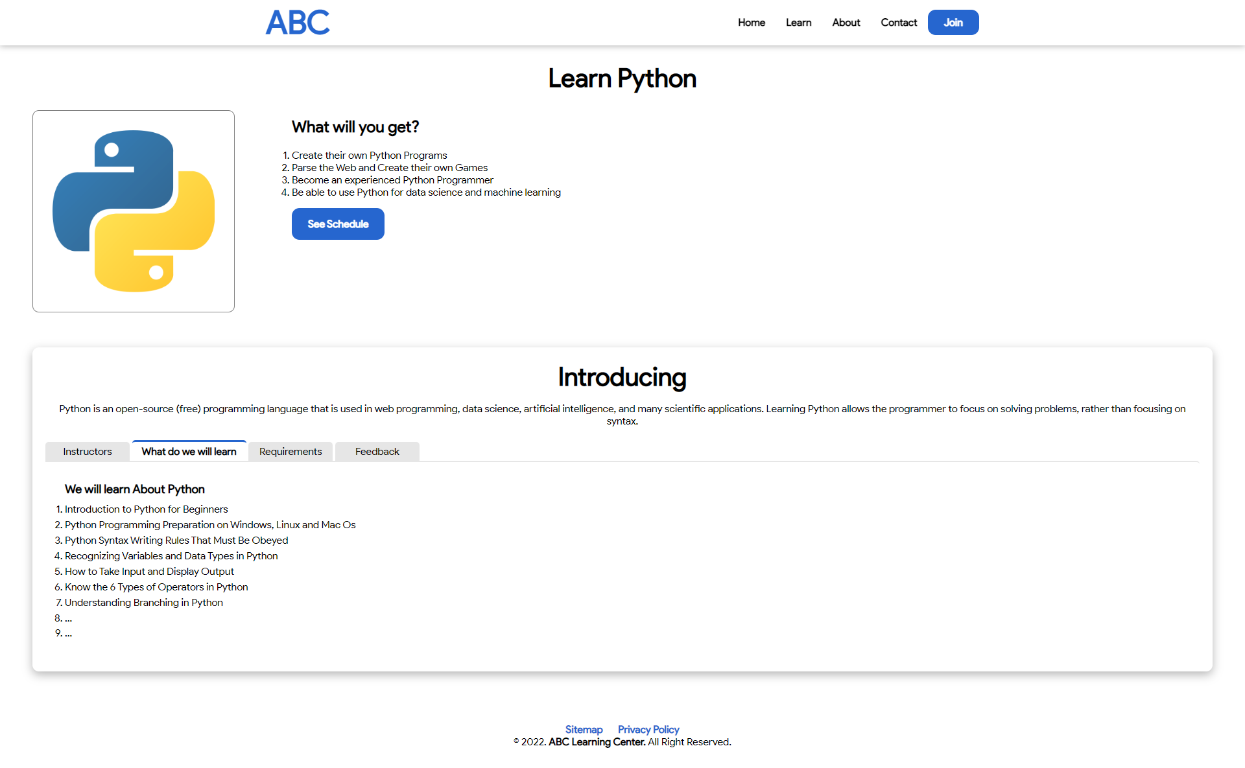

|  |  |
| --- | --- |
| Menu Bar Java Course | Menu Bar Python Course |

# Task 5

## Task Statement:

1. Write a paragraph on the effectiveness of the designed Lead Generation Administration System
2. Write briefly on effectiveness of the User Interface according to 2 metrics
3. Include it as part of Project Report

## Solution:

Lead generation is a powerful tool for promoting or advertising products or services. Lead generation is a technique for attracting potential customers and guiding or showing them your products or services in a unique and interesting manner. ABC Learning Center's target customers in this case are those with an interest in the field of information technology. To attract potential customers, ABC Learning Center will use their website to promote and showcase their products/offers, such as showing the benefits of applying for the courses, showing what they will learn, showing the company's origins, privacy policy, and each course schedule and subjects.

The most important part of a website's landing page is to entice a potential customer (visitor) to stay and look at the products or services on offer. With its new website, the ABC Learning Center will include "call-to-action" features or a display image that will pique the visitor's interest and curiosity. If a visitor stays on the website and browses around, they can fill out the "registration form" on the home page, which is marked with "Read More Button".

When a visitor submits a registration form, the ABC Learning Center staff is able to view the information immediately and will contact the visitor for further coordination or arrangements.

## Metrics for Lead Generation Form

* Easy To Use

The website will be able to use the feature without issue or difficulty. Because the form is simple, the visitor can complete it quickly. The Administration system is simple to use because it does not require any technical knowledge to operate. To click the button and fill out the form, all you need is a mouse and a keyboard.

* Code Efficiency

The code must be simple to read and easy to maintain. It must be clean, even if it requires a complex data structure. A complex design will cause problems with run-time performance. To optimize the run time, keep the business logic as simple as possible.

* Overall

All of the above will make the Lead Generation Form more effective in terms of increasing lead conversion and providing more complete and accurate lead information. Then, as a result of these factors, the administrator of ABC Learning Center is no longer required to perform unnecessary tasks in order to revalidate the lead's data.

# Task 6

## Task Statement:

1. Make changes to User Interface based on effectiveness metrics identified in Task 5
2. Make the changes to HTML, CSS & Javascript
3. Include the screen capture along with list of modifications made as part of the Project Presentation

## Solution:

This is discussed in the Project Presentation.

# Task 7

## Task Statement:

Create a User Guide for Lead Generation form and its Associated Administration Module

## Solution:

**Lead Generation Form**

* 1. At the Home page, click on the “See More” side of Laptop Picture

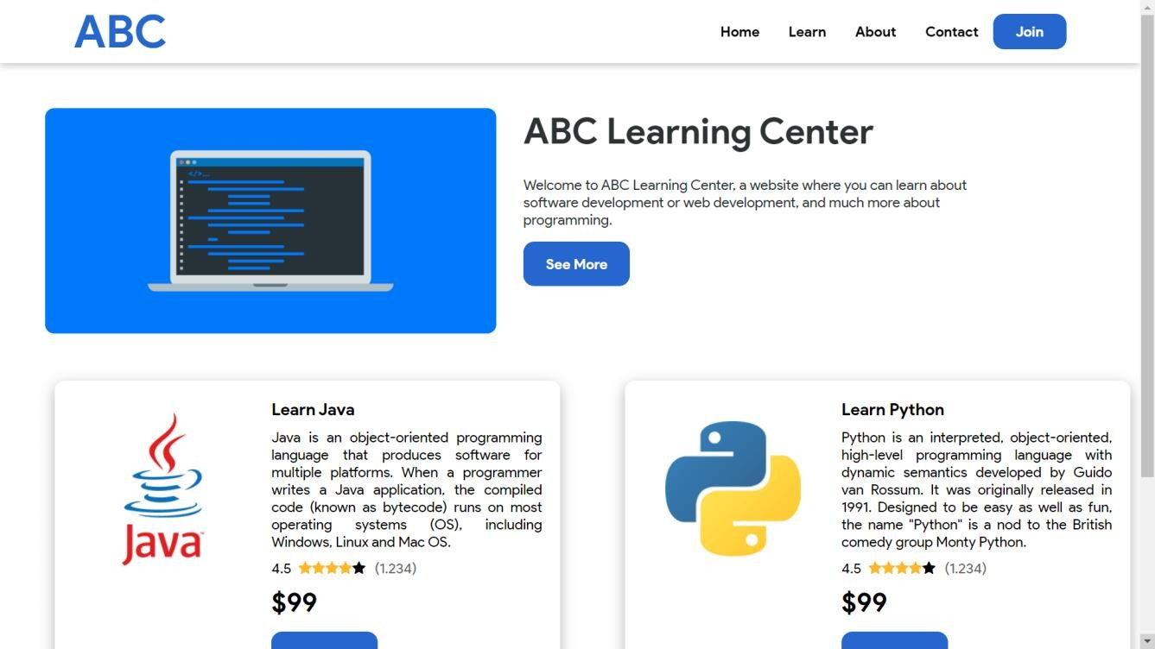

* 1. You will be redirected to Course Registration Page

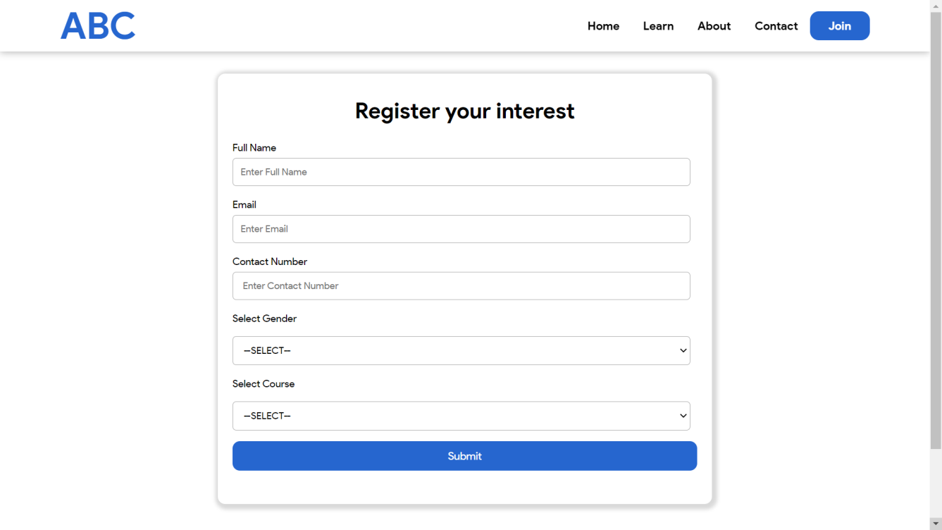

* 1. Fill up the form to input the followings.
     1. Enter the full name
     2. Enter the email
     3. Enter the contact number
     4. Select the gender
     5. Select the course
  2. Click ‘Submit’ button to submit the form into the system.

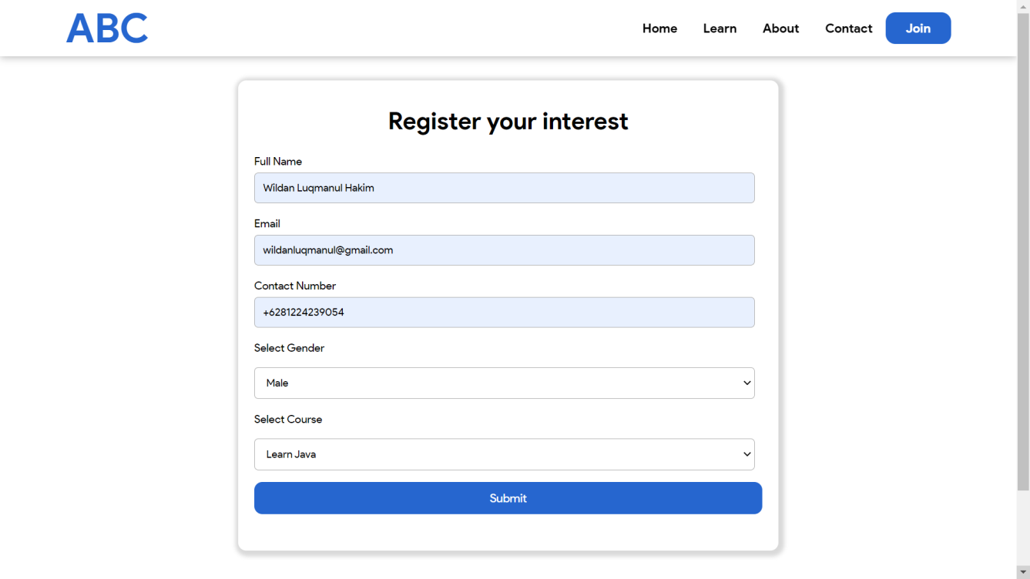

* 1. Upon submission, validation of fields will be done. If there’s any mistake, a guide will be displayed as shown below.

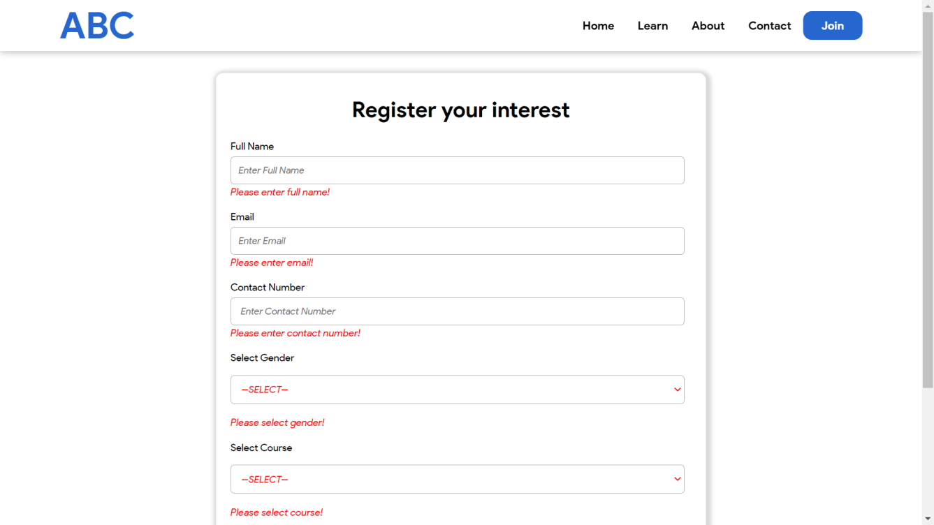

* 1. If all entries are validated correct, You will be redirected to Thank You Page as shown below.

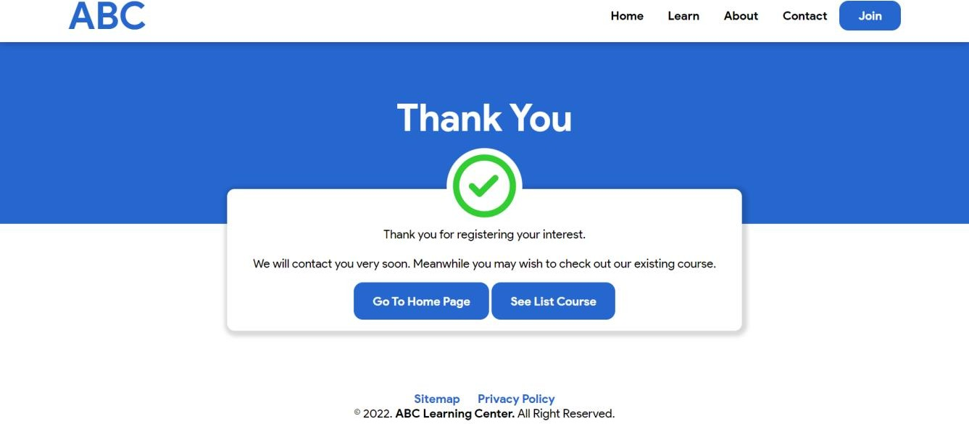

## Lead Administration System Leads Listing Page

**Add Lead**

1. 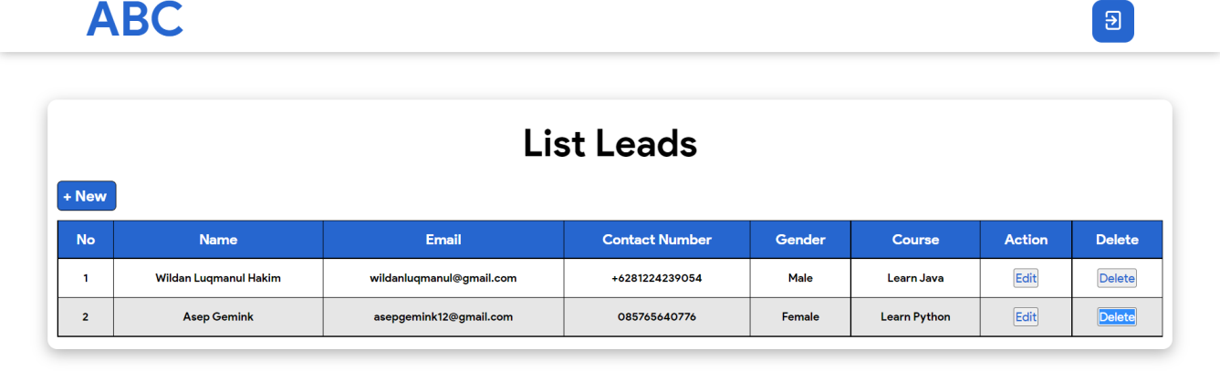Click on the “+New”
2. A pop-up form will be displayed as shown below.

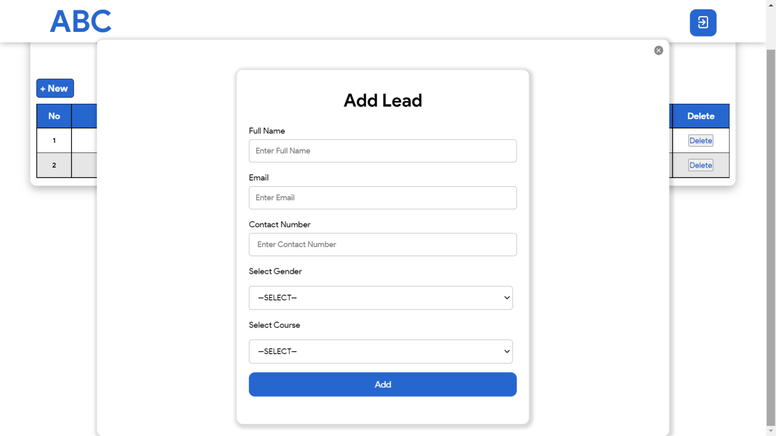

1. Fill up the form to input the followings.
   1. Enter the full name
   2. Enter the email
   3. Enter the contact number
   4. Select the gender
   5. Select the course

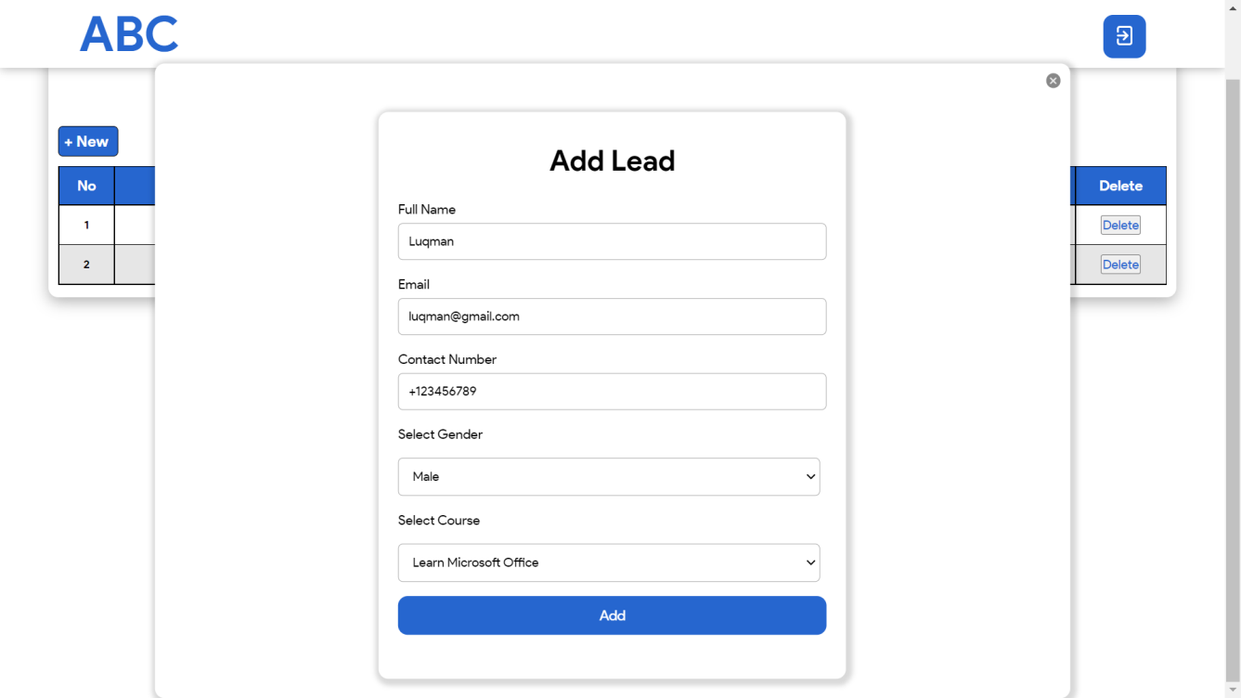

1. Click ‘Add’ button to create the new lead into the system.
2. Validation of fields will be done. If there’s any mistake, a guide will be displayed as shown below.

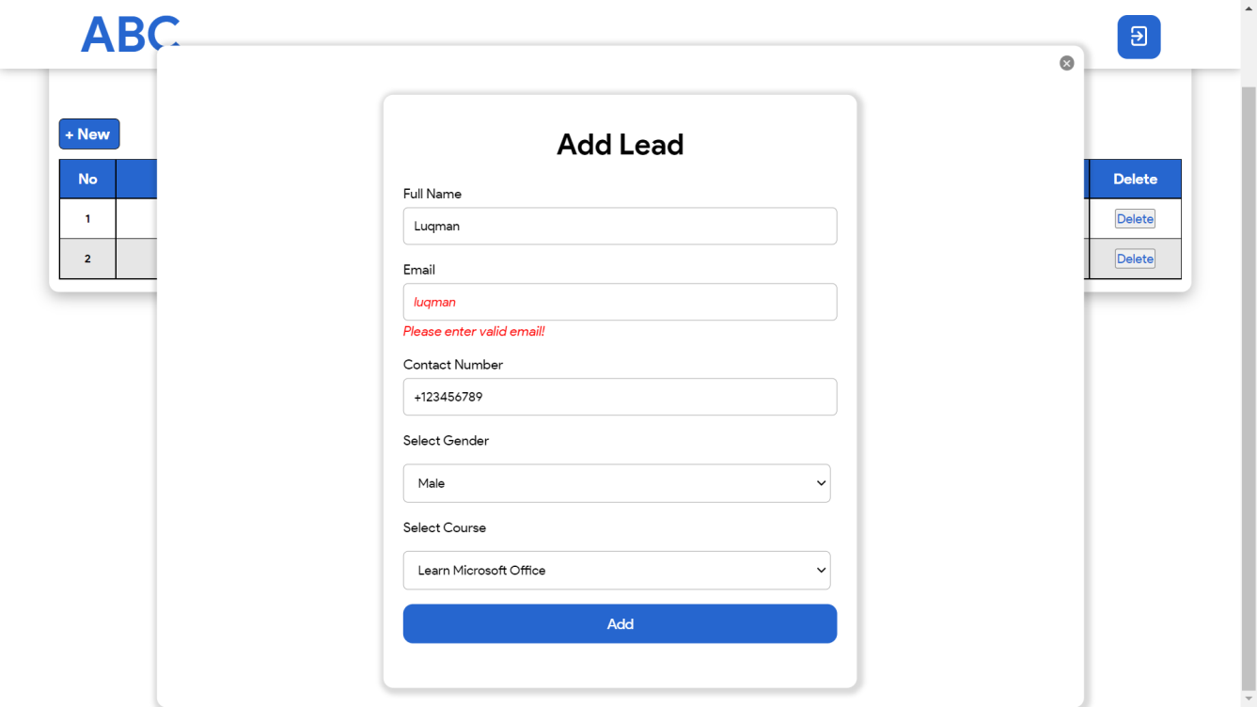

1. Click ‘close button’ at the top right to cancel the creation of the lead.

## Edit Lead

1. Click on the ‘Edit’ of row
2. A pop-up form will be displayed as shown below.

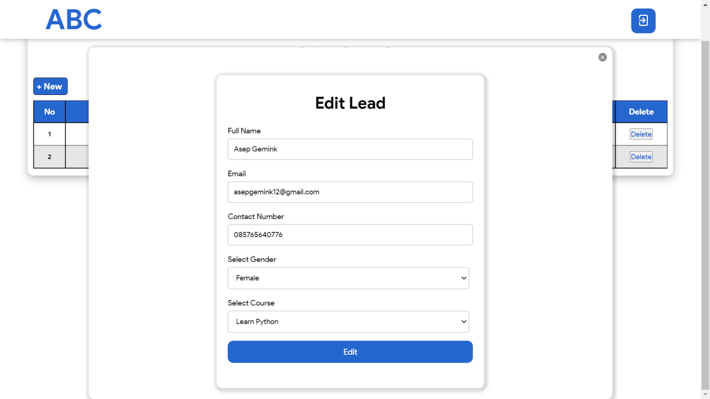

1. Make the required changes accordingly.
2. Click ‘Edit’ button to update the lead into the system.
3. Validation of fields will be done. If there’s any mistake, a guide will be displayed as shown below.

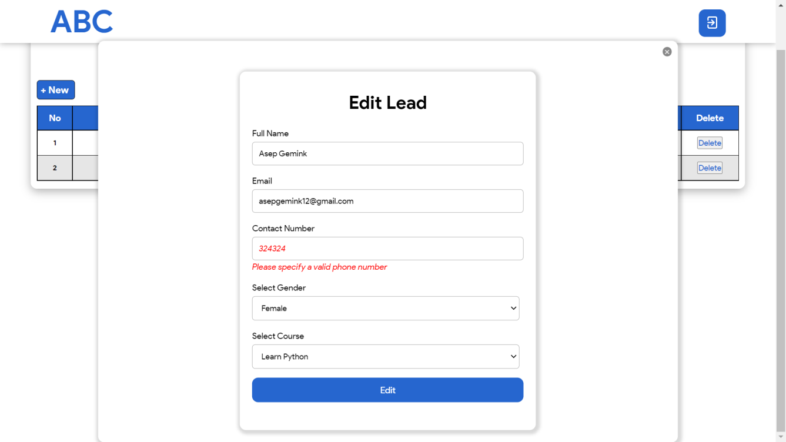

1. Click ‘close button’ at the top right to cancel the modification of the lead.

## Delete Lead

1. Click on the ‘Delete’ of row of the lead to remove.